Key Shasteen Locations in NW Ohio

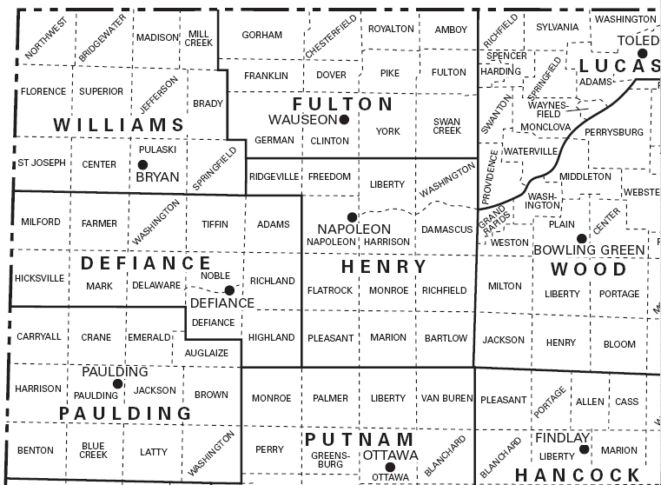

Edmund & William Shasteen Land in NW Ohio and where descendants are buried
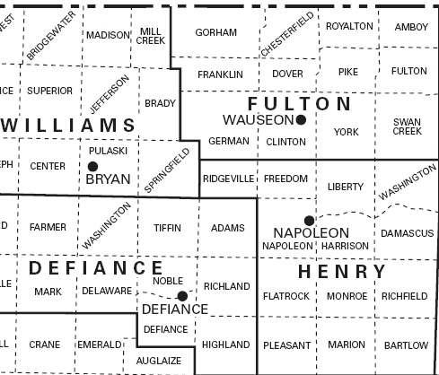 | Land Locations  Edmund  William  William’s deed in Williams County, prior to establishment  of Defiance County & assume Henry Co.  Burial Information:  Edmund descendants  West Jefferson Cemetery, Jefferson Twp., Williams Co.  Gilson (Union Chapel) Cemetery, Napoleon Twp., Henry Co.  Independence Cemetery, Richland Twp.,Defiance Co.  James b 1815 descendants  Wauseon Union Cemetery, Clinton Twp., Fulton Co., OH  Gilson (Union Chapel) Cemetery, Napoleon Twp., Henry Co  Forest Hill Cemetery, Napoleon Twp., Henry Co, OH
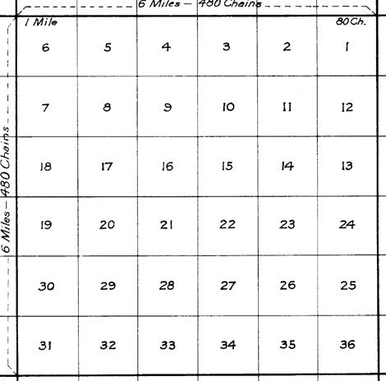 | Township Map with Section Numbering  William ShaNteen Land - Williams Shanteen of Williams County [Note that part of Defiance Co came from Williams Co. Feb 1826- Mar 1845] purchase of 40 acres dated 8 Oct 1835, "the south east quarter of the north east quarter of section eight in Township four north of range five east in the district of land subject to sale at Piqua Ohio containing forty acres." [This is Richland Twp, East border Central township of county, southwest from Napoleon Twp.]  Edmund Shasteen Land 1 Edmund Shasteen of Henry County Ohio purchase of 40 acres dated 7 Oct 1835 "the south east quarter of the north east quarter of section twenty one in township five north of range five east in the district of lands subject to sale at Wapaukonetta Ohion containing forty acres." [This is Adams Twp, NE corner of county, directly west of Napoleon Twp]  Edmund Shasteen Land 2 "the south west quarter of the north west quarter of section twenty two in township five north of range five east in the district of lands subject to sale at Wapaukonetta Ohio containing 40 acres." [This is Adams Twp, NE corner of county]
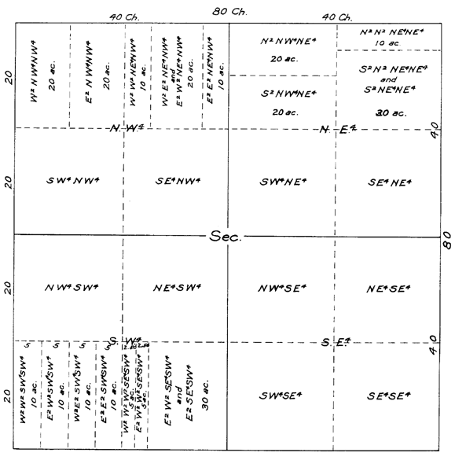 | Section Map with Numbering  William  Edmund  Edmund

Issues:
Need to verify that the township determinations are accurate. Have not been able to verify that the township numbers used in the deeds of 1835 are the same as the township numbers obtained from the county web page.
Particularly concerning is the reference in Williams documentation to his being from Williams County

Notes:

Ancestry.com record

William – Issue 8 Oct 1835 OH 40 Acres Acc # OH0620__.171 Land Office Piqua Canceled No, Mineral No, Authority April 24, 1820 Sale Cash Entry (3 Stat.566) Doc 1182 – Legal [Aliquot Parts: SENE] Section 8 Twp 4-N Range 5-E Meridian 1st PM Co Defiance [Believe this is the Township east of the one with Defiance in it or Richland]
Edward – Issue 7 Oct 1835 OH 40 Acres Acc # OH0650__.106 Land Off Wapakonetta Canceled No Mineral No Authority Same Doc 2659 Legal [Aliquot Parts: SENE] Section 21 Twp 5-N Range 5-E Meridian 1st PM Co Defiance [Believe this is the Township east of the one with Defiance in it and north, or Adams]
Edward – Issue 7 Oct 1835 OH 40 Acres Acc # OH0650__.107 Land Off Wapakonetta Canceled No Mineral No Authority Same Doc 2660 Legal [Aliquot Parts: SWNW] Section 22, Twp 5-N Meridian 1st PM Co Defiance
BLM Web resource site: http://www.glorecords.blm.gov/Visitors/PLSS.asp - Due to the tremendous amount of land sold in the 1800's, the General Land Office experienced quite a backlog in the middle part of the 19th century. It was not unusual for several years to pass between the time an individual purchased land from the local land office and the time a patent for that tract was finally signed by the GLO in Washington, D.C. The earliest land entry files, those dating from 1788 to the mid-1850's, generally contain little substantive genealogical information. They simply document a financial transaction or provide evidence of military service. Still, for some researchers just knowing that someone purchased land or received a bounty land warrant, that they were at a certain place at a certain time is often more information than they had before viewing the copies of the records.
Township / Range - The Township identifies a major subdivision of the public lands under the rectangular system of surveys. Most Townships measure approximately 6 miles on each side and contain approximately 23,040 acres. A Township is identified by its relationship to a base line and a principal meridian.
For example, "Township 5 South, Range 12 West, 5th Principal Meridian" identifies a particular township that is 5 tiers south from the base line of the 5th Principal Meridian.
The Range is used in conjunction with the Township data field identifies a row or tier of townships lying east or west of the principal meridian and numbered successively to the east or west from the principal meridian. In the example "Township 5 South, Range 12 West," the number 12 represents the Range Number that is used to identify the township that is 12 tiers to the west of the principal meridian.
Section Number - The Section Number identifies a tract of land, usually 1 mile square, within a township. Most townships contain 36 sections. Standard sections contain 640 acres. A section number identifies each section within a township.
Aliquot Parts - Using the rectangular system of survey, lands were divided into Townships containing 6 square miles. Each Township was subdivided into 36 Sections, each containing approximately 640 acres. Each Section was further subdivided into halves and quarters, repeatedly, until the parcel of land was accurately described. Without the use of Fractional Sections, Blocks, or Lots (in the case of uneven parcels of land), Aliquot Parts were used to represent the exact subdivision of the section of land. Halves of a Section (or subdivision thereof) are represented as N, S, E, and W (such as "the north half of section 5"). Quarters of a Section (or subdivision thereof) are represented as NW, SW, NE, and SE (such as "the northwest quarter of section 5"). Sometimes, several Aliquot Parts are required to accurately describe a parcel of land. For example, "ESW" denotes the east half of the southwest quarter containing 80 acres and "SWNENE" denotes the southwest quarter of the northeast quarter of the northeast quarter containing 10 acres. It is important to remember that the Aliquots shown in the data base (e.g., "SWNENE") usually translates into words found on the land document.
In General: - - a section contains 640 acres, - - a half section contains 320 acres, - a quarter section contains 160 acres, - - a half of a quarter contains 80 acres, - - a quarter of a quarter contains 40 acres, etc.

