01  02  03  04  05  06  07  08  09  10  11  12  13  14  15  16  17  18  19  20  21  22  23  24  25  26  27  28  29  30  31  32  33  34  35  36  37  38  39  40 | 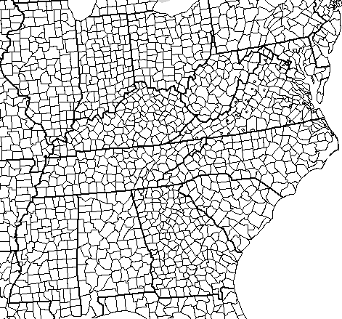 | 41  42  43  44  45  46  47  48  49  50  51  52  53  54  55  56  57  58  59  60  61  62  63  64  65  66  67  68  69  70  71  72  73  74  75  76  77  78  79  80

Legend
Objective is to visually map the early migration of Shasteen/Chastain first and second generation dispersion from VA to determine likely geographic locations of possible interaction.
01. Note: Color coding for following: Ohio Shasteens, Jesse Shasteen, brother James  02. Pierre Chastain’s descendants – 1st John, 2nd Peter, 3rd Rene  03.  04.  05.  06.  07.  08. Logan Co IL – OH Nancy Shasteen b 1787, son Edward b 1817, dau Nancy b 1824  09.  10. Piatt Co IL – OH Robert 1) son James b 1807 son James Shasteen b 1834, 2) son William’s sons Edward b 1839, Lewis Clark b 1832, William Finley b 1856  11. Jefferson Co IN – Jesse Shasteen b 1755 son Samuel 1788-1836  12. Scott Co IN – Peter Jr son William b 1744 sons Valentine 1768-1843, John 1781-1871?  13. Washington Co IN – Peter Jr son William b 1744 sons George 1766-1854, Robert Ranson 1770-1840, Barnett 1774-1857 and Rene 1776-1860  14.  15. Madison Co KY (James and Jesse moved to what is now Rockcastle Co formed 1810 from Knox, Lincoln, Madison, and Pulaski)  16.  17.  18. Gallatin Co IL – Jesse Shasteen b 1755 son Jesse Jr 1800-1841  19. Hardin Co KY – John b 1690 grandson Lewis 1766-1814  20. Warren Co KY – John b 1690 grandson John 1765-1829, Rene SP b 1743/50, Joseph 1771-1807, Isham 1777-1846  21. Logan Co KY – Rene SP b 1743/50 son Jacob 1781-1873  22.  23. Wayne Co KY – Jesse Shasteen b 1755  24. Coffee Co TN – Jesse Shasteen b 1755 many descendants this area  25.  26.  27.  28.  29.  30.  31.  32.  33.  34.  35. | 36.  37.  38.  39.  40.  41. Beaver Co PN – OH – Robert Shasteen daus Mary A Shasteen Ewing b ~1798, Rosanna Shasteen b 1799 via Ross, Henry, Defiance OH  42. Henry Co OH – OH – Robert Shasteen bros William & Edmund Shasteen  43. Defiance Co OH -  44. Ross Co OH – OH Robert Shasteen b `1781  45. Gallia Co OH – OH Shasteen initial migration from Amherst to Ross, Defiance, Henry  46.  47. Bath Co KY – Rene b 1713 son Rene Jr b 1741 son Martin 1768-1816  48. Garrard Co KY (from Madison 1796/7) – James & Nancy son Jesse b 1795  49. Nelson Co VA – formerly Amherst, Albemarle Co  50. Rockbridge Co VA –  51. Buckingham Co VA –  52. Amherst Co VA – Ohio Shasteen origination, James Shasteen  53. Bedford Co VA – John b 1690 son John Jr 1721-1777  54. Franklin Co VA  55.  56.  57. Rockcastle Co KY (was part of Madison Co)– James & Nancy Kennedy Shasteen deaths  58. Wilkes Co NC – Jesse Shasteen b 1751 wife Elinor Wade’s first husband Arcelaus Coffee county of death  59. Scott Co TN became Campbell, Fentress (west one co) and Morgan (south of Fentress – James & Nancy Shasteen son Johnson Shasteen b 1792  60. Warren Co TN – Rene SP b 1743/50 son John 1783-1810  61. Buncombe Co NC – Peter Jr son James 1740-1820  62. Rutherford Co NC – Peter Jr son Abraham 1743/50-1821  63. Franklin Co TN – Jesse Shasteen b 1755  64. Greenville Co SC – Peter Jr son Abraham 1743/50-1821  65. Pendleton Co SC – Peter Jr sons James 1740-1820, John 1743-1805  66. Abbeville Co SC – Rene b 1713 son Peter b 1736 son John b 1765  67.  68. Edgefield Co SC – Rene b 1713 son Peter 1736- pre 1800  69.  70.

Copyright © 2014, All rights reserved

