01  02  03  04  05  06  07  08  09  10  11  12  13  14  15  16  17  18  19  20  21  22  23  24  25  26  27  28  29  30  31  32  33  34  35  36  37  38 | 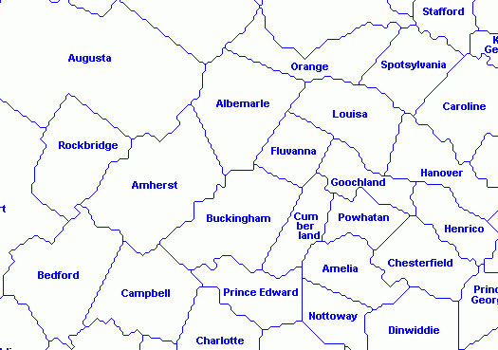 | 01  02  03  04  05  06  07  08  09  10  11  12  13  14  15  16  17  18  19  20  21  22  23  24  25  26  27  28  29  30  31  32  33  34  35  36  37  38

Legend
Objective is to locate present day approximate locations of Shasteen/Chastain families and holdings on the 1790 key counties in VA
(Amherst later split to form Nelson from the top half circa 1807, and in 1845 part of Buckingham, Campbell, Prince Edward to form Appomattox
01. ttox
02.
03.
04.
05.
06.
07. John Chastain Jr. (assume b 1721), Jane Chastain (not known as spouse/unmarried offspring) witness 7 Jun 1760 Moseley to Leseur 400 acre sale in Albemarle (Now Buckingham)
08.
09.
10.
11.
12.
13.
14.
15.
16. Pierre Chastain Jr b 1707 - 1 Dec 1740 Goochland to Albemarle to Buckingham 400 acre patent on both sides of Hunt’s Creek, indicated with two lines above
and 16 Aug 1756 patented 396 acres in Albemarle on the branches of Hunt’s Creek
17.
18.
19. Jesse Shasteen b 1755 and wife Elinor 13 Apr 1789 sale 50 acres North fork of Davises Creek
20. Present day Amherst
21.
22. James Sharsted Jr b circa pre 1721 — 11 Nov 1751 sold 150 acres to Cabell on braches of Huff’s Creek east side Tobacco Row Mountains (east of city of Amherst) probably his 1 Apr 1949 150 acre land grant (James Shastood)
23.
24. James Sharstead b circa pre 1721 — 20 Aug 1748 witness sale of 580 A from John Thrasher to James Smith 400 acres both sides Buffaloe near Blue Mts., pat 1 Feb 1738, also 388 acres adj grantor the river. Davis path, Buffalo River pat 20 Sep 1745 Blue Ridge Mountain, also known as Blue Mountain, is the colloquial name of the western most ridge of the Blue Ridge Mountains in northern Virginia and the Eastern Panhandle of West Virginia
25. Rane Chastain b 1713 — 9 May 1752 witness Holt selling 215 acres on Buffalo Creek branches adj Rane Chastain, then Albemarle now Buckingham
26. Stephen Chastain b 1690 early land grants in Henrico and Goochland 1716-1728 and 1730-1736
27. Pedlar Mills
28.
29. James Shasteen 17 Jun 1799 purchase 100 acres from Ambrose Gatewood on Otter Creek and 15 May 1812 and Sep 1812 sales of 133 and 100 acres on both sides Otter Creek
30.
31.
32. James "Buff" Shasteen (Sharstead / Shastead / Chastain) — James "J River" Shasteen and brothers James "Ped" and Jesse Shasteen circa 1785 general area
33.
34.
35. Franklin Co – William Chastain b 1744 (Pierre2, Pierre1) – Property Tax Rolls 1790 and 1799, also sons George, Valentine, Robert and Barnett
Copyright © 2014, All rights reserved

