01  02  03  04  05  06  07  08  09  10  11  12  13  14  15  16  17  18  19  20  21  22  23  24  25  26  27  28  29  30  31  32  33  34  35  36  37  38  39  40  41  42  43  44  45 | 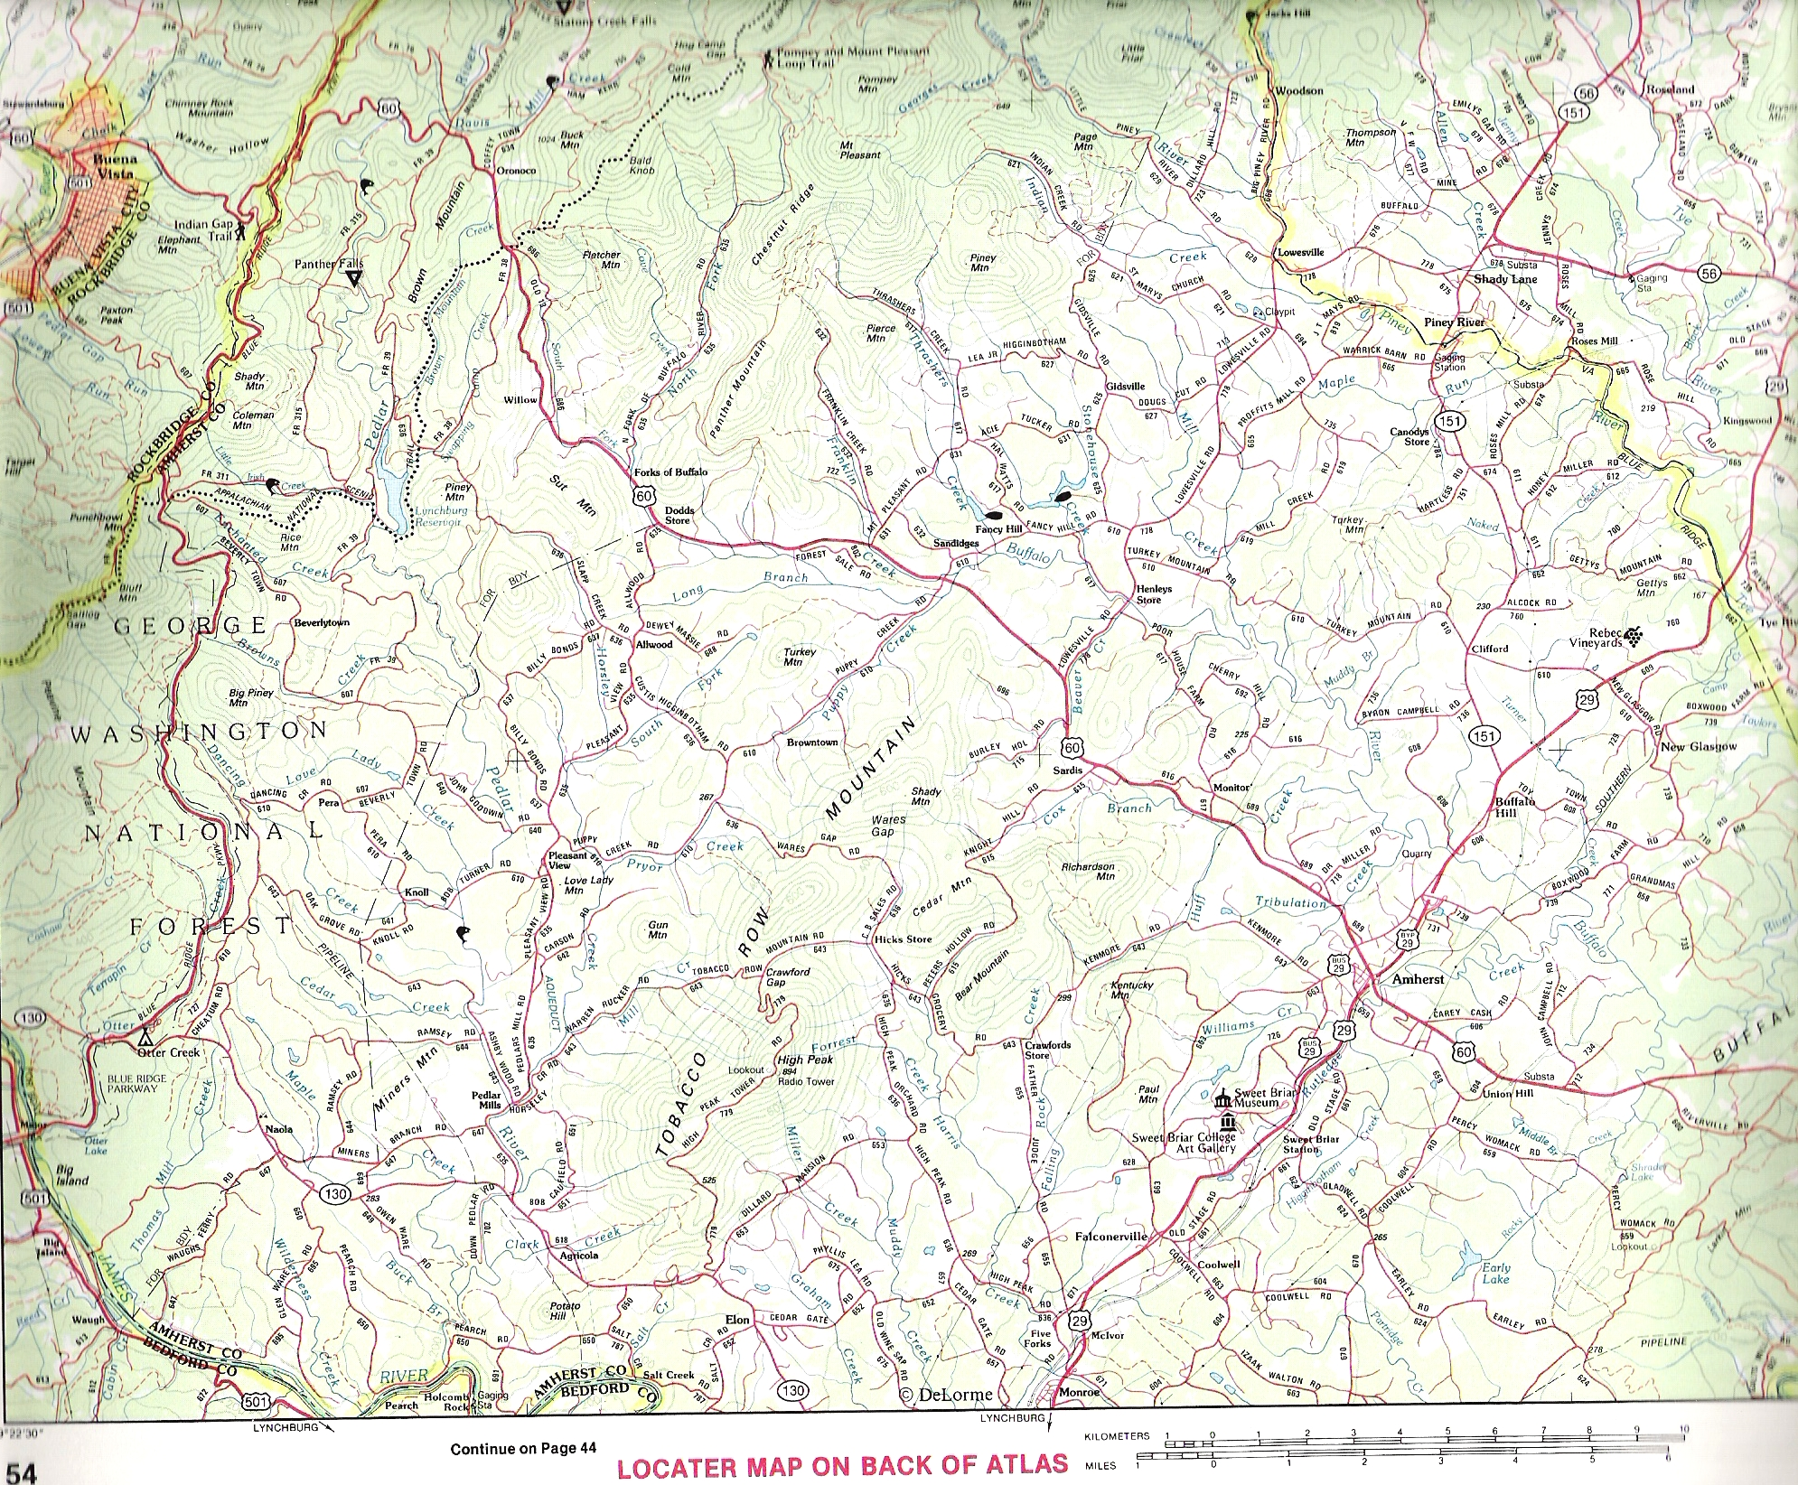 | 01  02  03  04  05  06  07  08  09  10  11  12  13  14  15  16  17  18  19  20  21  22  23  24  25  26  27  28  29  30  31  32  33  34  35  36  37  38  39  40  41  42  43  44  45

Legend – Note: These placements are very loose and speculative. I have not been successful in finding a method to place these old land holdings.
Source: Virginia Atlas & Gazetteer by DeLorme Mapping Company © 1989, Approximately one half page per scan
Objective is to estimate location of early Shasteen land transactions and landmarks on a detail map of southwest Amherst County, VA.
01. Bedford Co bottom of page, Rockbridge to the left and above, Nelson Co to the right and above - Note yellow tinting of county lines - Pisgah Hill, Rockbridge Co- Off of map to the top left
02.
03.
04.
05. 13 Apr 1789 Shasteen, Jesse, wife Elinor and Elizabeth Wade to Jacob Puckett for 35£, recorded in 1789 in land tax alterations North fork of Davises Creek, formerly owned by John Wade...James Cull's line...William Allen's part...Archibald Coffey's (Jesse married his widow Elinor) (Note proximity of Davis Mill Creek and Coffey Town Rd on the current map, as well as Pedlar River)
06.
07.
08.
09. Shasteen, James "Buff", "Ped", "J River" and Jesse circa 1785
10. 20 Aug 1748 Sharstead, James witness, sale of 580 A from John Thrasher to James Smith both sides Buffaloe near Blur (Blue?) Mts
11.
12.
13.
14.
15.
16.
17. Forks of Buffalo
18. Buffalo Creek, Amherst Co - NE of Mountain in Tobacco Row Mountain
19.
20.
21.
22.
23.
24.
25.
26. 11 Nov 1751 Sharstead, James 150 acres on the head branches of Huffs Creek on the side of the Tobacco Row Mountain- this appears to be near here
27. 01 Apr 1749 James Shastood 150 Acre land grant head branches of Huffs Creek and on the side of the Tobacco Row Mountains
28.
29.
30. Huff Creek, Amherst Co - about 3 miles W NW of Amherst
31.
32. Tobacco Row Mountain, Amherst Co -
33. City of Amherst - Follow Hwy 29 from above the work Atlas N to Hwy 60
34. Otter Creek, Amherst Co - Blue Ridge Parkway follows Otter Creek from Hwy 501 in the lower left corner. Note Otter Lake also. Suspect Otter Creek property closer to James River to have sufficient flow to power a mill. Believe location of 17 Jun 1799 Shastead (& Shattead), James 100 A from Ambrose Gatewood, Sr on Otter Creek, 15 May 1812 James Shastead, Sen 130A to John & R.S. Ellis Both sides Otter Creek and the mill and all the premises (Never found purchase) 14 Sep 1812 Shartead James, Jr. & wife Phoebe 100A to John & R.S. Ellis et al - Both sides of Otter Creek – This may be between Otter Lake and the James River
35.
36.
37.
38. Pedlar Mills, Amherst Co - About 4 miles above the word Continue at the bottom of the map
39. Pedlar River (Creek) appears to start at point 7 and run down to point 6
40.

Copyright © 2014, All rights reserved

